A Very Special Christmas

Celebrating the Birth of Christ at the Birth Place of Christianity in Aotearoa New Zealand

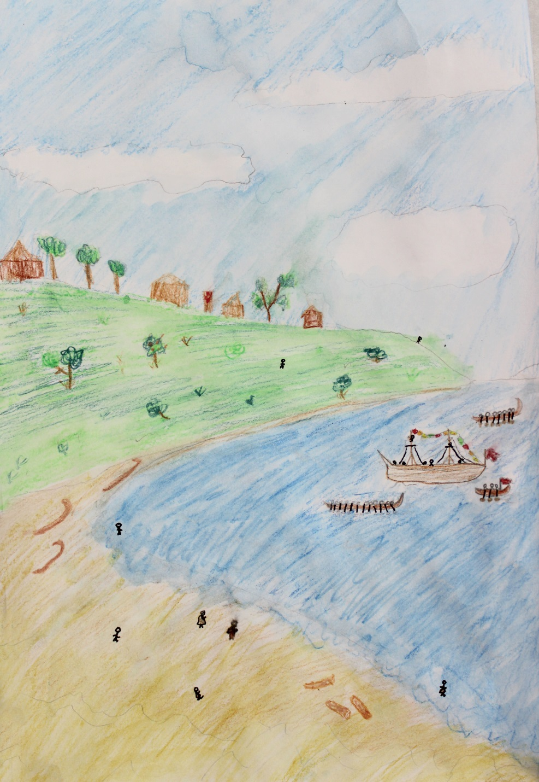
Artwork by Ella Riley, Year 5 student, Diocesan School for Girls, Auckland

A Bicentenary Ecumenical Service of Thanksgiving
Oihi, Christmas Day 2014
“Kia whai kororia te Atua i runga rawa, kia mau te rongo ki runga ki te whenua, me te whakaaro pai ki nga tangata.”
“Glory to God in the highest, and on earth peace, good will towards all”
- Luke 2:14

We welcome you to Oihi as we celebrate the bicentenary of the service of worship which inaugurated the first Christian mission in Aotearoa New Zealand. On this day in 1814, Ruatara welcomed Samuel Marsden to this place, and the Gospel was proclaimed to Maori gathered here.
Today’s service has been planned by a group representing many of the churches, and is led by an ecumenical group of church leaders from across the country. We are glad that you are here today to join us in celebrating that event.
Please feel welcome to stay after the service and walk around the site. Enjoy a picnic lunch. Please remember to take all your belongings and any rubbish with you at the end of the day.
The service is being broadcast live by TVNZ. To maximise their access to signal, please turn cell phones to “flight mode” during the service.
You are welcome to take photos or use handheld video cameras but we ask that tripods or other equipment are not set up. A recording of the service will be available for purchase in the New Year.
Nau mai, haere mai.

The Gathering
The Most Reverend Brown Turei welcomes the people and reads the Sentence.
Behold I bring you good news of great joy; for to you is born in the city of David a Saviour, who is Christ the Lord.
- Luke 2:10,11

Remembering Christmas 1814
The Reverend Samuel Marsden’s recollection of the 1814 Christmas service in Aotearoa New Zealand.
The Reverend Dr Richard Waugh:
[On Christmas Eve, Chief Ruatara] enclosed about half an acre of land with a fence, erected a pulpit and reading-desk in the centre, and covered the whole, either with black native cloth, or some duck which he had brought with him from Port Jackson [Sydney]. He also procured some bottoms of old canoes and fixed them up as seats on each side of the pulpit for the Europeans to sit upon; intending to have Divine service performed there the next day. These preparations he made of his own accord; and in the evening, informed me that everything was ready for Divine service. I was much pleased with this singular mark of his attention. The reading-desk was about three feet from the ground and the pulpit about six feet. The black cloth covered the top of the pulpit and hung over the sides. The bottom of the pulpit as well as the reading desk was part of a canoe. The whole was becoming and had a solemn appearance. He had also erected a flag-staff on the highest hill in the village, which had a very commanding view…

The National Anthem

E Ihowa Atua God of nations at thy feet
O ngā iwi mātou rā, in the bonds of love we meet.
āta whakarongo na; Hear our voices, we entreat,
Me aroha noa. God defend our free land.
Kia hua ko te pai; Guard Pacific’s triple star
Kia tau tō atawhai; From the shafts of strife and war,
Manaakitia mai Make her praises heard afar,
Aotearoa. God defend New Zealand.

Dr Adrienne Puckey:
About ten o’clock [on Christmas morning] we prepared to go ashore to publish the glad tidings of the Gospel for the first time. I was under no apprehensions for the safety of the vessel, and therefore ordered all on board to go on shore to attend Divine service, except the master and one man. When we landed we found Korokoro, Ruatara [Duaterra], Hongi Hika [Shunghee] dressed in regimentals which Governor Macquarie had given them, with their men drawn up ready to march into the enclosure to attend Divine service. They had their swords by their sides and a switch in their hands. We entered the enclosure and were placed in the seats on each side of the pulpit. Korokoro marched his men on and placed them on my right hand in the rear of the Europeans and Ruatara [Duaterra] placed his men on the left. The inhabitants of the town with the women and children and a number of other chiefs formed a circle round the whole. A very solemn silence prevailed–the sight was truly impressive. I got up and began the service with the singing of the Old Hundred Psalm, and felt my very soul melt within me when I viewed my congregation and considered the state they were in.

Hymn
1.  All people that on earth do dwell,  Sing to the Lord with cheerful voice.  Him serve with fear, His praise forth tell;  Come ye before Him and rejoice. | 3.  O enter then His gates with praise;  Approach with joy His courts unto;  Praise, laud, and bless His Name always,  For it is seemly so to do.
2.  The Lord, ye know, is God indeed;  Without our aid He did us make;  We are His folk, He doth us feed,  And for His sheep He doth us take. | 4.  For why? the Lord our God is good;  His mercy is for ever sure;  His truth at all times firmly stood,  And shall from age to age endure.
5.
To Father, Son and Holy Ghost,
The God Whom Heaven and earth adore,
From us and from the angel-host
Be praise and glory evermore.
Text: William Kethe Tune: Old 100th, Louis Bourgeois

Mr Glyn Carpenter:
After reading the service,… it being Christmas Day, I preached from the Second Chapter of St. Luke’s Gospel, and tenth verse: “Behold! I bring you glad tidings of great joy.” The Natives told Ruatara [Duaterra] that they could not understand what I meant. He replied that they were not to mind that now for they would understand by and by, and that he would explain my meaning as far as he could. When I had done preaching, he informed them what I had been talking about. Ruatara [Duaterra] was very much pleased that he had been able to make all the necessary preparations for the performance of Divine service in so short a time, and we felt much obliged to him for his attention. He was extremely anxious to convince us that he would do everything for us that lay in his power and that the good of his country was his principal consideration. In this manner the Gospel has been introduced into New Zealand; and I fervently pray that the glory of it may never depart from its inhabitants, till time shall be no more.

Hymn
1.
Not on a snowy night
By star or candlelight
Nor by an angel band
There came to our dear land

Chorus
Te Harinui
Te Harinui
Te Harinui
Glad tidings of great joy

2.
But on a summer day
Within a quiet bay
The Maori people heard
The great and glorious word

3.
The people gathered round
Upon the grassy ground
And heard the preacher say
I bring to you this day

4.
Now in this blessed land
United heart and hand
We praise the glorious birth
And sing to all the earth
Text and Tune: Willow Macky (1921-2006)

The Ministry of the Word

Isaiah 52:7-10 The Reverend Tovia Aumua
How beautiful upon the mountains are the feet of the messenger who announces peace, who brings good news, who announces salvation, who says to Zion, ‘Your God reigns.’ Listen! Your sentinels lift up their voices, together they sing for joy; for in plain sight they see the return of the Lord to Zion. Break forth together into singing, you ruins of Jerusalem; for the Lord has comforted his people, he has redeemed Jerusalem. The Lord has bared his holy arm before the eyes of all the nations; and all the ends of the earth shall see the salvation of our God.
Luke 2:1-16 Associate Professor Mānuka Hēnare (reading first in Te Reo Maori)
In those days a decree went out from Emperor Augustus that all the world should be registered. This was the first registration and was taken while Quirinius was governor of Syria. All went to their own towns to be registered. Joseph also went from the town of Nazareth in Galilee to Judea, to the city of David called Bethlehem, because he was descended from the house and family of David. He went to be registered with Mary, to whom he was engaged and who was expecting a child. While they were there, the time came for her to deliver her child. And she gave birth to her firstborn son and wrapped him in bands of cloth, and laid him in a manger, because there was no place for them in the inn.
In that region there were shepherds living in the fields, keeping watch over their flock by night. Then an angel of the Lord stood before them, and the glory of the Lord shone around them, and they were terrified. But the angel said to them, ‘Do not be afraid; for see, I am bringing you good news of great joy for all the people: to you is born this day in the city of David a Saviour, who is the Messiah, the Lord. This will be a sign for you: you will find a child wrapped in bands of cloth and lying in a manger.’ And suddenly there was with the angel a multitude of the heavenly host, praising God and saying, ‘Glory to God in the highest heaven, and on earth peace among those whom he favours!’
When the angels had left them and gone into heaven, the shepherds said to one another, ‘Let us go now to Bethlehem and see this thing that has taken place, which the Lord has made known to us.’ So they went with haste and found Mary and Joseph, and the child lying in the manger.

The Sermon – The Most Reverend Philip Richardson
Musical Item
Students from the Bay of Islands International Academy will sing
Thanksgivings and Intercessions
Major Steven Jarvis, Pastor Mike Griffiths, Pastor Iliafi Esera, Pastor Mark Whitfield, & The Reverend David Moko will offer prayers on various topics, each being followed by the response:
Lord, in your mercy
Hear our prayer

The prayers conclude with the Lord’s Prayer, as follows:

Kua akona nei tatou e to tatou Ariki, ka inoi tatou

E tō mātou Matua i te rangi  Kia tapu tōu Ingoa.  Kia tae mai tōu rangatiratanga.  Kia meatia tāu e pai ai  ki runga ki te whenua,  kia rite anō ki tō te rangi.  Hōmai ki a mātou āianei  he taro mā mātou mō tēnei rā.  Murua ō mātou hara,  Me mātou hoki e muru nei  i ō te hunga e hara ana ki a mātou.  Aua hoki mātou e kawea kia whakawaia;  Engari whakaorangia mātou i te kino:  Nōu hoki te rangatiratanga, te kaha,  me te korōria, Āke āke āke. Āmine. | Our Father in heaven,  hallowed be your name,  your kingdom come,  your will be done,  on earth as in heaven.  Give us today our daily bread.  Forgive us our sins  as we forgive those  who sin against us.  Save us from the time of trial  and deliver us from evil.  For the kingdom, the power,  and the glory are yours now and for ever. Amen.

Hymn

1.
Joy to the world, the Lord is come!
Let earth receive her King;
Let every heart prepare him room,
And heav’n and nature sing,
And heav’n and nature sing,
And heav’n, and heav’n and nature sing.

2.
Joy to the world, the Saviour reigns!
Let all their songs employ;
While fields and floods, rocks, hill and plains
Repeat the sounding joy,
Repeat the sounding joy,
Repeat, repeat the sounding joy.

3.

He rules the world with truth and grace,

and makes the nations prove
The glories of his righteousness
and wonders of his love,
and wonders of his love,
and wonders, wonders of his love.

Text: Isaac Watts (1674-1748) Tune: Antioch

An Act of Corporate Recommitment to Christ and Invitation to Faith
The text of this statement comes from ‘A discussion paper for the Gospel Bicentenary, Aotearoa New Zealand’ and was agreed by an ecumenical group of church leaders.

The Right Reverend Andrew Norton
“The early missionaries believed in a God who would ultimately work out all things according to his own sovereign plan. In the same way we believe that, in spite of human failings and limitations, the Creator’s purposes will be established in these islands. We believe too, in the rule and reign of the Kingdom of God, which like a small kauri sapling grows to become a tree, giving life to many things.

Like many who have gone before, we seek to fashion ways of life and faith that are both faithful to Christian scripture and tradition and, at the same time, authentically indigenous to this land of Aotearoa New Zealand.

In line with scriptural principles and the promise of a new world where justice reigns, we affirm our commitment to the proclamation of the Gospel and to work for a renewed society in which the great potential of human life within these islands will be fully realised.”
Let us, as twenty-first century followers of Jesus Christ in this land of Aotearoa New Zealand, recommit ourselves to Christ, his message and his mission”.

God’s call through Christ is to all people. The work of Ruatara and Samuel Marsden was one of invitation and welcome. Today that invitation and welcome is as real as ever. You may not have made a formal commitment to Christ before, but you are welcome to join with Christians now to affirm your trust in Jesus.

The Venerable Carole Hughes What is your faith?
All I believe and trust in God the Father, maker and sustainer of all things; and in God the Son, my Saviour Jesus Christ; and in God the Holy Spirit, giver of life and truth. This is my faith.
Leader Christians are called to a way of life which reflects the love of God shown to us in Jesus Christ.
Will you commit yourself to this life?
All I will, with God’s help.
Leader Will you forgive others as you are forgiven?
All I will, with God’s help.
Leader Will you seek to love your neighbour as yourself, and strive for peace and justice?
All I will, with God’s help.
Leader With the whole Church will you proclaim by word and action the Good News of God in Christ?
All I will, with God’s help.

Concluding Prayer The Right Reverend Te Kitohi Pikaahu
E te Atua o te Moana-nui-a-Kiwa, me enei motu, o te iwi Maori, to iwi Pakeha, me ratou katoa a noho nei i tenei wahi. Ka whakamoemiti, ka whakawhetai ki a koe mo tenei whenua o matou; mo nga mea pai katoa kua whiwhi tahi nei matou. Whakanuia to matou aroha tetahi ki tetahi, whakakahangia to matou whai i te tika kia kotahi ai matou i runga i te whakaaro kotahi. Kua hanga matou a koe hei toto kotahi; i raro i tenei whakaaro kotahi: ko Ihu Karaiti nei to matou Ariki. Amine
God of the southern sea and of these islands, of Maori, Pakeha, and of all who dwell in our land; we give you thanks and praise for our country, and for what we have achieved together. Increase our trust in one another; strengthen our quest for justice, and bring us to unity and a common purpose. You have made us of one blood; make us also of one mind. We make this prayer through Jesus Christ our Lord. Amen
God of our nation, you have called us to care for one another;
cleanse our eyes to see each other clearly;
open our hearts to know our own mistakes;
build in us respect for each other’s taonga;
help us to do justice to one another
and to hope together.
In Jesus’ name we pray.
Amen.

The Peace
The Most Reverend Winston Halapua prays Christ’s peace on the Congregation

The Peace of Christ be always with you
And also with you.
The whole congregation are invited to exchange a sign of peace
Hymn
1.
O Come All Ye Faithful
Joyful and triumphant,
O come ye, O come ye to Bethlehem.
Come and behold Him,
Born the King of Angels;
O come, let us adore Him,
O come, let us adore Him,
O come, let us adore Him,
Christ the Lord.
2.
Sing, choirs of angels,
Sing in exultation,
Sing all ye citizens of heaven above.
Give to God in the Highest;
O come, let us adore Him,
O come, let us adore Him,
O come, let us adore Him,
Christ the Lord.
3.
Yea, Lord, we greet Thee,
Born this happy morning,
Jesus, to thee be glory given.
Word of the Father, now in flesh appearing;
O come, let us adore Him,
O come, let us adore Him,
O come, let us adore Him,
Christ the Lord.

Concluding Prayers of Thanksgiving – The Right Reverend Ross Bay &
The Right Reverend Te Kitohi Pikaahu

Creator of all, you chose the Ngapuhi Chief, Ruatara,
to prepare a way for the Christian missionaries to Aotearoa;
may the gateway that he opened for the Gospel
encourage us to look for every means
by which your word may be proclaimed;
through Jesus Christ our Lord. Amen

Gracious and eternal God, you called Samuel Marsden
to lead the first mission to the Maori people;
grant that, following in his footsteps,
we may bring to this land the good news
of great joy in Jesus Christ our Saviour.
Amen

Loving God, you have called your church to bear witness
that in Christ you are reconciling all people to yourself;
help us to proclaim your love in word and deed,
so that all may grasp the hope that is in Jesus Christ our Lord.
Amen
Almighty God, you gave your only-begotten Son to take our nature upon him, and be born of the Virgin Mary; grant that we, who have been born again and made your children by adoption and grace, may daily be renewed by your Holy Spirit; through our Saviour Jesus Christ, who lives and reigns with you and the Holy Spirit, one God now and for ever. Amen
Holy and ever-living God,
by your power we are created
and by your love we are redeemed;
guide and strengthen us by your Spirit,
that we may give ourselves to your service,
and live each day in love to one another and to you,
through Jesus Christ our Lord.
Amen.

The Dismissal
The Most Reverend Brown Turei blesses the Congregation.
Christ, who by his incarnation, gathered into one all things earthly and heavenly, fill you with joy and peace and the blessing of God our Creator, Redeemer and Giver of life be with you always. Amen.
Go now to love and serve the Lord. Go in peace.
Amen. We go in the name of Christ. Kororia ki te Atua!

Hymn
1.  Hark! The herald angels sing,  “Glory to the newborn King;  Peace on earth, and mercy mild,  God and sinners reconciled!”  Joyful, all ye nations rise,  Join the triumph of the skies;  With th’ angelic host proclaim,  “Christ is born in Bethlehem!”  Hark! the herald angels sing,  “Glory to the newborn King!” | 2.  Christ, by highest Heav’n adored;  Christ the everlasting Lord;  Late in time, behold Him come,  Offspring of a virgin’s womb.  Veiled in flesh the Godhead see;  Hail the incarnate Deity,  Pleased as man with us to dwell,  Jesus, our Emmanuel.  Refrain
3.
Hail the heav’nly Prince of Peace!
Hail the Sun of Righteousness!
Light and life to all He brings,
Ris’n with healing in His wings.
Mild He lays His glory by,
Born that we no more may die,
Born to raise us from the earth,
Born to give us second birth.
Refrain
Text: Charles Wesley (adapted) Tune: F Mendelssohn

Churches involved in leading the Bicentenary Service
The Anglican Church of Aotearoa, New Zealand and Polynesia - Te Hahi Mihinare ki Aotearoa, ki Niu Tireni, Ki Nga Moutere of te Moana Nui a Kiwa
The Most Reverend Philip Richardson – Primate and Bishop of Taranaki
The Most Reverend Brown Turei – Primate and Pihopa of Te Tairawhiti
The Most Reverend Dr Winston Halapua – Primate and Bishop of Polynesia
The Right Reverend Te Kitohi Pikaahu – Pihopa of Tai Tokerau
The Right Reverend Ross Bay – Bishop of Auckland
The Venerable Carole Hughes – Archdeacon of Auckland
Dr Adrienne Puckey – Member of Bicentenary Planning Group

The Methodist Church of New Zealand – Te Haahi Weteriana O Aotearoa
The Reverend Tovia Aumua – President

The Catholic Church in Aotearoa New Zealand – Te Hahi Katorika ki Aotearoa
Associate Professor Mānuka Hēnare

The Wesleyan Methodist Church of New Zealand
The Reverend Dr Richard Waugh – National Superintendent

The Presbyterian Church of Aotearoa New Zealand
The Right Reverend Andrew Norton – Moderator of the General Assembly

The Lutheran Church of New Zealand – Te Hahi Rutana o Aotearoa
Pastor Mark Whitfield – Bishop

Elim Church of New Zealand
Pastor Mike Griffiths – National Leader

Assemblies of God in New Zealand
Pastor Iliafi Esera – General Superintendent

Baptist Churches of New Zealand
The Reverend David Moko – Kaihautu, Baptist Maori Ministries

Salvation Army New Zealand
Major Stephen Jarvis – Northern Division Commander

Vision Network of New Zealand
Mr Glyn Carpenter – National Director

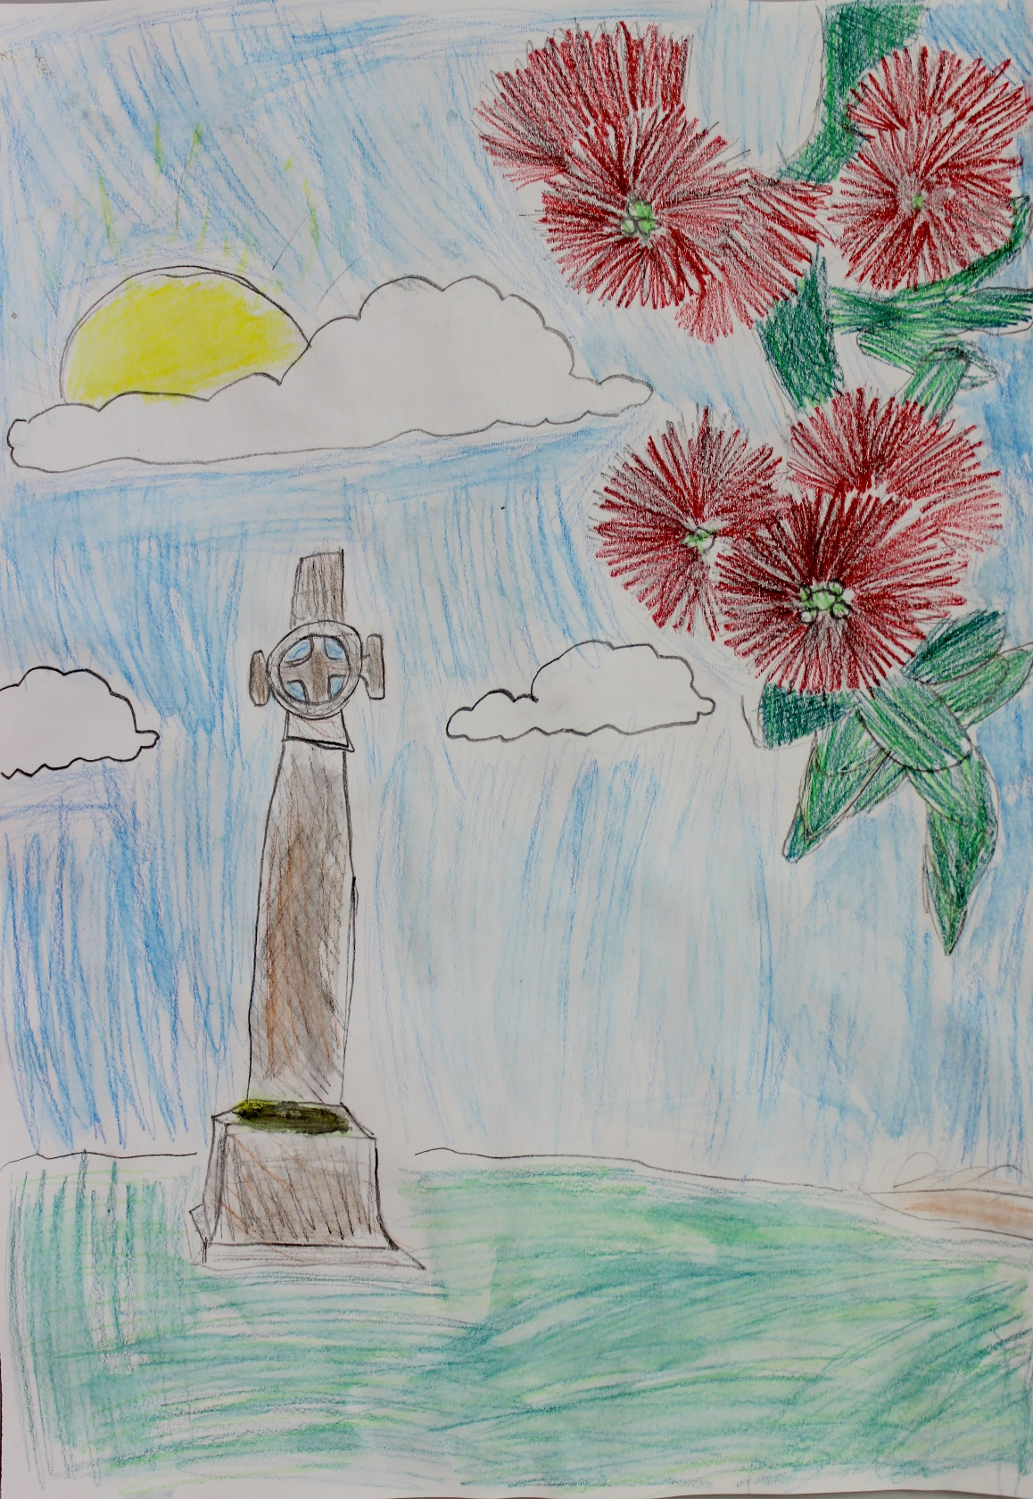
Artwork by Phoebe O’Neill, Year 5 student, Diocesan School for Girls, Auckland

Members of the Bicentenary Ecumenical Planning Group

Anglican Church Bishop Ross Bay, Bishop Te Kitohi Pikaahu, Dr Adrienne Puckey and Rev Michael Hughes;
Baptist Church Rev David Moko; Catholic Church Ms Adriana Janus; Methodist Church Rev Dr Trevor Hoggard and
Rev Andrew Gamman; Presbyterian Church Rev Ray Coster and Rev Andrew Norton;
Vision Network of NZ Mr Glyn Carpenter; Wesleyan Methodist Church Rev Dr Richard Waugh;
Secretary Mrs Lesley Anderson Communications Officer Rev Jayson Rhodes

